MEMORANDUM

TO: Area Agency on Aging Executive Directors
Notice #: 060407-1-I-SWCBS
FROM: E. Douglas Beach, Secretary

DATE: June 1, 2007

SUBJECT: Notice of Instruction: Comprehensive Assessment and Review for Long Term Care Services (CARES) Referrals
_________________________________________________________________

The purpose of this notice is as follows:
- Explain how referrals made by Comprehensive Assessment and Review for Long Term Care Services (CARES) staff to the area agency on aging (AAA) and lead agencies are recorded in the Client Information and Registration Tracking System (CIRTS),
- Describe the AAA’s CIRTS-related responsibilities for referrals received by CARES,
- Describe the reassessment policy as it applies to CARES referrals, and
- Provide information about CIRTS reports as they relate to CARES referrals.

1. How Referrals Made by CARES Are Tracked in CIRTS
Referrals made by CARES to the AAA or lead agency requires CARES to hand-deliver, mail or fax a referral form and assessment. The assessment and referral information must be entered into CIRTS by CARES staff prior to the referral being made. If the CARES assessment and referral information have not been entered into CIRTS by CARES when the referral is received, the AAA or lead agency should contact the supervisor at the CARES office from which the referral was sent.

2. AAA’s CIRTS-Related Responsibilities For Referrals Received by CARES

Acknowledging Referrals in CIRTS
In CIRTS, referrals made by CARES are tracked in the CARES Referral screen. The imminent risk designation is recorded in the CARES Referral screen along with the date the referral was made. Starting on the day your planning and service area converted to the new statewide CIRTS application, the AAA or lead agency is responsible for entering the date the hard-copy referral is received in the “Date Received” field in the CARES Referral Information screen for all referrals made to the AAA or to lead agencies. This is the only field in the CARES Referral Information screen that is editable by the AAA and lead agency (and not editable by CARES staff). This field must be populated within one week of receiving the referral. (See Accessing the Referral Screen in CIRTS below for instructions on how to access the CARES Referral Information screen. See CIRTS Conversion Chart below for a listing of the dates each PSA converted to the new statewide CIRTS application.)

Charlie Crist

GOVERNOR

E. Douglas Beach, Ph.D.

SECRETARY

4040 ESPLANADE WAY
TALLAHASSEE
FLORIDA, 32399-7000

phone 850.414.2000
fax 850.414.2004
TDD 850.414.2001

http://elderaffairs.state.fl.us

Entering Enrollment Information in CIRTS
The CIRTS Enrollment Screen must be updated for the referred individual. An entry is needed for each program in which the referred individual is enrolled. An entry is also needed for each program for which the individual is waiting.

3. Reassessing CARES Referrals

The CIRTS application allows assessments performed by CARES to be viewed by the AAA and lead agencies. This eliminates the need for the AAA and lead agencies to reassess or reenter assessments performed by CARES. As such, performing “updates” on assessments performed by CARES is not necessary for individuals referred by CARES unless a significant change has occurred to the functional or medical status of the individual since the assessment was performed.

4. CIRTS Reports

New Reports

A new exception report is available that identifies referrals made by CARES that have not been updated in CIRTS by the AAA or lead agency with the date the referral was received. This report is titled “CARES Referrals Not Acknowledged By The Aging Network.” It is available on the CIRTS Reports Page in the Miscellaneous section. This report should be run frequently to ensure all CARES referrals have been received and the imminent risk designation is known.

Current Reports
Current reports have been updated to include individuals identified as imminent risk by CARES.

Accessing the Referral Screen in CIRTS
The new CARES Referral Information screen is accessible from the CIRTS Client Demographics screen via the “Referrals” button. The Client Demographics screen is shown on the following page.

Client Demographics Screen
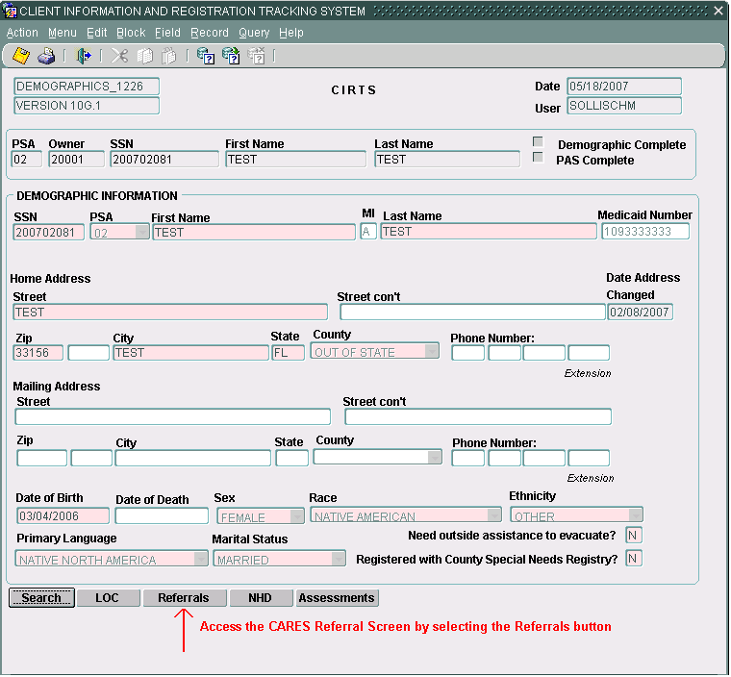

After clicking on the “Referrals” button, the CARES Referral Information screen is displayed. The new CARES Referral Information screen is shown below:

CARES Referral Information Screen
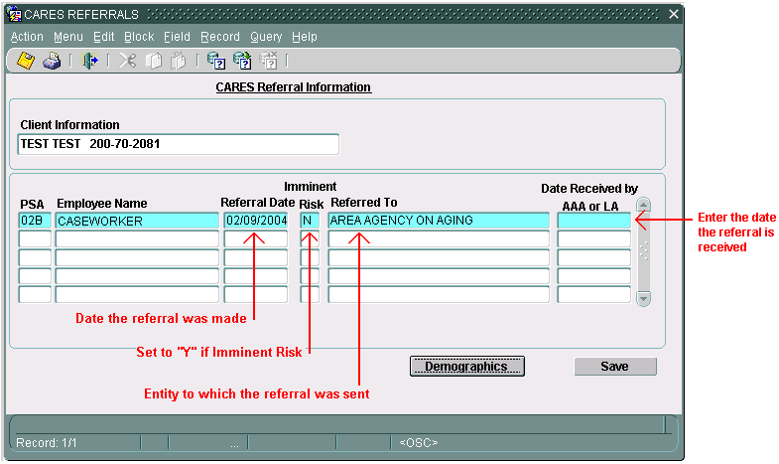

The date the referral was made is displayed along with the imminent risk designation (N= not imminent risk; Y= imminent risk). Only referrals made to the AAA or lead agency require the “Date Received by the AAA or LA” field be updated (“Referred To” is set to Area Agency on Aging or Lead Agency. The AAA or lead agency acknowledges receipt of the referral by clicking into the field “Date Received by AAA or LA” and typing in the date the hard-copy referral is received. Click the “Save” button to save all changes made. Click the “Demographics” button to return to the Client Demographics screen.

CIRTS Conversion Chart

PSA | Date Converted to Single Statewide CIRTS
PSA 1 | August 17, 2006
PSA 2 | July 13, 2006
PSA 3 | December 14, 2006
PSA 4 | November 16, 2006
PSA 5 | October 19, 2006
PSA 6 | November 30, 2006
PSA 7 | February 15, 2007
PSA 8 | August 29, 2006
PSA 9 | September 14, 2006
PSA 10 | February 28, 2007
PSA 11 | January 25, 2007

Please contact Mindy Sollisch at (850) 414-2181 or via email at Sollischm@elderaffairs.org if you have any questions or comments regarding this notice.

EDB/mjs

cc: Contract Managers
Marcy Hajdukiewicz

