Summary:
FL eCIRTS is configured to NOT allow Duplicate SSN. The 'Unknown" value is 111-11-1111.
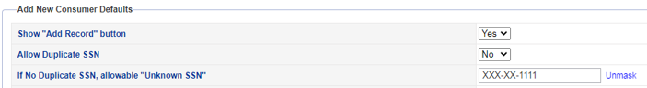
The Allow Duplicate SSN functionality is not recognizing the allowed "unknown" value causing a hard stop for end users on the assessments. Unfortunately, this issue was not identified during the build validation process, so a solution doesn't already exist.
WellSky Development is fixing this issue. A temporary configuration change to the assessment forms is needed to implement a work around until the fix can be identified, built, tested and deployed.
Users will also encounter this issue using 111-11-1111 on the Consumer > Demographics page. No configuration changes are needed to implement a work around. The SSN field is not required on the Demographics page so the work around is just to leave the field blank.

Work Around:
We have added a new "Pseudo SSN?" question on the assessments.

When it is checked, the required SSN field goes away.
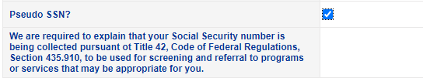

The SSN field disappears instead of the user entering 111-11-1111.
The DOEA Report writing team will create a report and use this new question to identify records that may need clean up, once the issue is fixed. A HAR report can list all assessments where this field was used. A manual effort would be needed to validate the SSN is correct on these records once the 111-11-1111 SSN can be used again.

Next Steps:
- The 701S, 701A, 701B and 701C will be updated in Production the evening of 9/1/22.
- Instruction to end users: Do not use 111-11-1111. Leave SSN blank on Client > Demographics instead of using 111-11-1111.
- Instruction to end users: Do not use 111-11-1111. Use the new "Pseudo SSN" field on the assessments which will hide the required SSN field, instead of adding 111-11-1111.
- These processes will be in place until a permanent fix is made. The timeline is not known at this time but will be managed by the SCTF during the Tuesday meetings.

