## eCIRTS Client Codes

* New fields have been added to the eCIRTS Client Enrollments screen to capture client codes similar to the client codes that existed in Legacy CIRTS. These codes are used to indicate reasons why a client who may not normally be eligible for the program is enrolled, or are used to indicate that a client may be receiving services after their date of death or after going active with the MLTC program. Ultimately, having these codes associated with the client’s records will enable DOEA, including the Monitoring and Quality Assurance (MQA) team, to discern legitimate reasons for these client being enrolled or served. The exception reports that can be run out of eCIRTS will be updated to include these client codes. For example, when users run the report titled ‘Consumer Age Verification Report’, which shows clients under 60 who are receiving services, they will be able to see which of those clients have one of these codes, and therefore may not be exceptions. The list of codes which will be available in eCIRTS is as follows.
  + MLTC
    - Service Extension for MLTC Active Client
  + Client Under 60
    - Spouse
    - Volunteer
    - Disability (resident)
    - Disability (accompanying client)
    - Alzheimer’s Disease or related Dementia
  + Date of Death
    - Case Closure
    - Vital Statistics SSN Error – Client confirmed Living
  + Nutrition
    - Nutrition Counseling Services refused

These codes can be added to the enrollment found on the “Programs” tab on a client’s record in eCIRTS. Once a user clicks on the relevant program enrollment, the two new fields “Enrollment Exception” and “Exception Reason” are now available to capture these codes. The following screenshot from the eCIRTS Sandbox shows how the two new fields look:

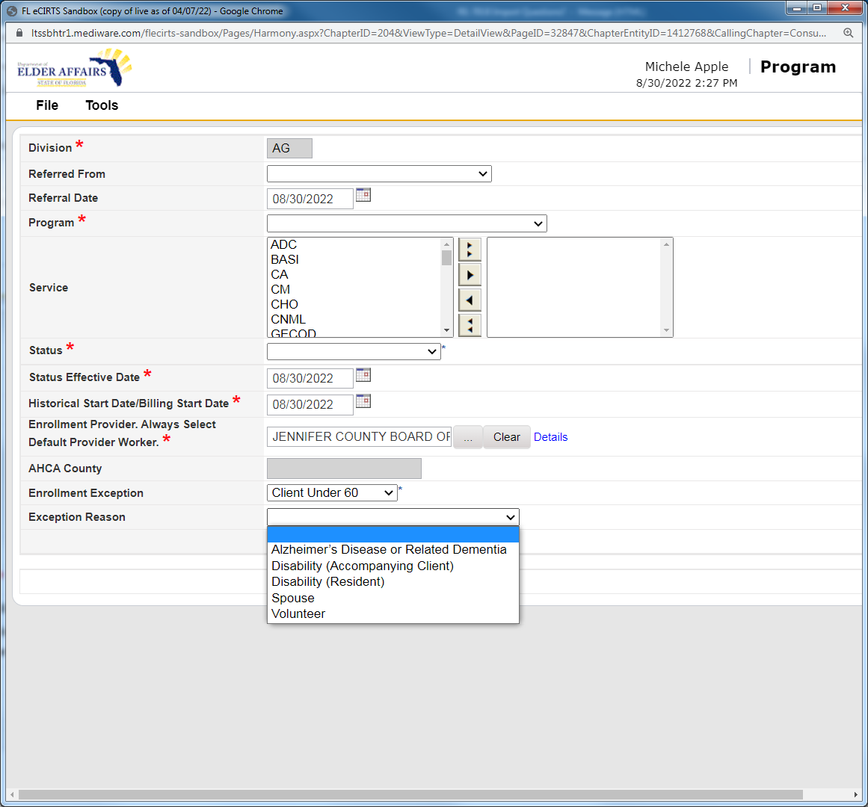

* Additional questions regarding this data or regarding updates to the eCIRTS reports may be directed to the eCIRTS Reports Team at [ecirtsreports@elderaffairs.org](mailto:ecirtsreports@elderaffairs.org). Programmatic questions regarding what clients can be associated with these codes should be directed to your OAA/GR contract manager.